

|  |  |  |  |  |  |  |  |  |
| --- | --- | --- | --- | --- | --- | --- | --- | --- |
|  | | | | | | | | |
|  | | FINAL PROJECT ON BACKORDER PREDICTION | | | | |  | |
|  |  | | | | | | |  |
|  | | | |  |  | | | |
|  | | | | MANUJ GANERIWALALUV TIWADI |  | | | |
|  | | | | 21-09-23—Summer Internship in Data Science and Machine Learning—Mr.Rishu Dwivedi |  | | | |
|  | | |  | | |  | | |



|  |  |  |  |  |  |  |  |  |
| --- | --- | --- | --- | --- | --- | --- | --- | --- |
|  |  | | |  |  | | |  |
|  | INTRODUCTION | | | | | | |  |
|  |  | | |  |  | | |  |
|  |  | |  | | |  | |  |
|  |  |  | **Project Overview:**  Backorders are unavoidable, but by anticipating which things will be backordered, planning can be streamlined at several levels, preventing unexpected strain or delays on production, logistics, and transportation.  ERP systems generate a lot of data (mainly structured) and also contain a lot of historical data; if this data can be properly utilized, a predictive model to forecast backorders and plan accordingly can be constructed.  Based on past data from inventories, supply chain, and sales, we will classify the products as going into backorder (Yes or No).  **Project objective:**  Our aim is to leverage the power of data analytics to classify whether the Product will be Backordered or not which can significantly enhance the productivity and profit.  Development of a predictive model for Predicting Product Backorders. The model will determine whether a customer is placing a Backorder or not.  The classical machine learning tasks like Data Exploration, Data Cleaning, Feature Engineering, Model Building and Model Testing. We will Try out different machine learning algorithms that’s best fit for the above case. | | |  |  |  |
|  | | | | |
|  |  |  |  |
|  |  |





|  |  |  |  |  |
| --- | --- | --- | --- | --- |
|  |  |  |  |  |
|  | TECHNOLOGY USED | | |  |
|  |  |  |  |  |
|  | PYTHON Python has syntax that allows developers to write programs with fewer lines than some other programming languages. Python runs on an interpreter system, meaning that code can be executed as soon as it is written. This means that prototyping can be very quick.  Python language is being used by almost all tech-giant companies like – Google, Amazon, Facebook, Instagram, Dropbox, Uber… etc. Python is currently the most widely used multi-purpose, high-level programming language, which allows programming in Object-Oriented and Procedural paradigms. | | |  |
|  | NUMPY   It provides a high-performance multidimensional array object, and tools for working with these arrays. It is also used for algebraic calculations and mathematical calculations. In Python we have lists that serve the purpose of arrays, but they are slow to process NumPy aims to provide an array object that is up to 50x faster than traditional Python lists.  The array object in NumPy is called ndarray, it provides a lot of supporting functions that make working with ndarray very easy. |  |  |  |

##### PANDAS

##### 

Pandas allows us to analyze big data and make conclusions based on statistical theories.

Pandas can clean messy data sets, and make them readable and relevant.

It has functions for analyzing, cleaning, exploring, and manipulating data.

The name "Pandas" has a reference to both "Panel Data", and "Python Data Analysis“.

**Pandas**is an**open-source library** in**Python** that is made mainly for working with relational or labeled data both easily and intuitively. It provides various data structures and operations for manipulating numerical data and time series. This library is built on top of the [NumPy](https://www.geeksforgeeks.org/python-numpy/)library of Python. Pandas is fast and it has high performance & productivity for users.

##### SCIKIT-LEARN



Scikit-learn (Sklearn) is the most useful and robust library for machine learning in Python. It provides a selection of efficient tools for machine learning and statistical modeling including classification, regression, clustering and dimensionality reduction via a consistence interface in Python

Simple and efficient tools for data mining and data analysis. It features various classification, regression and clustering algorithms including support vector machines, random forests, gradient boosting, k-means, etc.



|  |  |  |  |  |
| --- | --- | --- | --- | --- |
|  |  |  |  |  |
|  | THE PROCESS | | |  |
|  |  |  |  |  |
|  | The task is to classifying whether a product will go to backorder or not for a given input data. This is a Binary Classification Problem hence consists of two target values :Yes: Represents that product will go to backorder.No: Represents that product will not go to backorderDATA COLLECTION For working on Backorder Prediction problem we are using dataset available on Kaggle.  We will Gather historical data , previous data, information from reliable sources.    **DATASET:**   * **SKU :** Product ID * **national_inv :** Current inventory levels of components. * **Lead_time :** Transit time of the product which means how long it takes for a shipment to be delivered at its final destination after it has been picked from the start point. * **in_transit_qty :** Amount of products in transit from source. * **Forecast columns:** Tells about the forecast sales of the products for next 3,6,9 months. * **Sales columns :** Sales quantity for prior 1,3,6 and 9 months time period. * **min_bank :** Minimum amount of stocks recommended. * **Pieces_past_due :** Amount of parts of the product overdue if any. * **Performance average :** Product performance over past 6 months and 12 months respectively. * **deck_risk,oe_constraint,ppap_risk,stop_auto_buy,rev_stop :** Yes or No flags set for the products. * **went_on_backorder :** Target Variable. | | |  |
|  | EDA (EXPLORATARY DATA ANALYSIS): In Exploratory data analysis (EDA),We have analyze and investigate data sets and summarize their main characteristics, often employing data visualization methods. It helps determine how best to manipulate data sources to get the answers we need, making it easier for usto discover patterns, spot anomalies, test a hypothesis, or check assumptions |  |  |  |

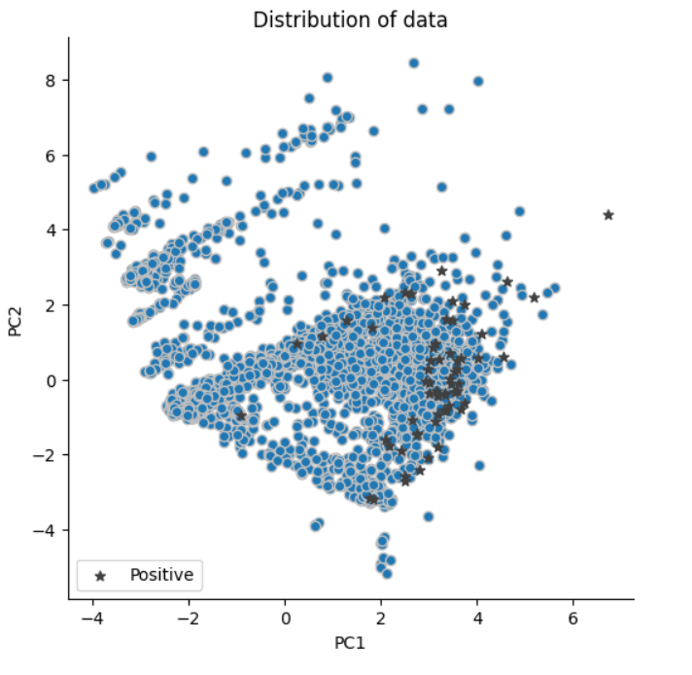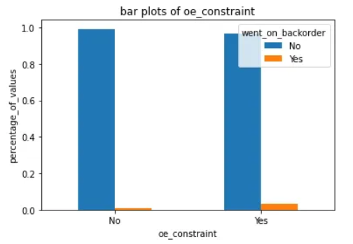 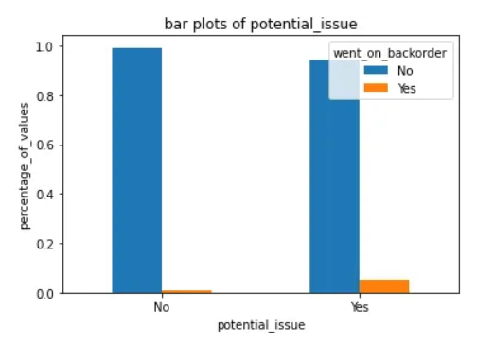

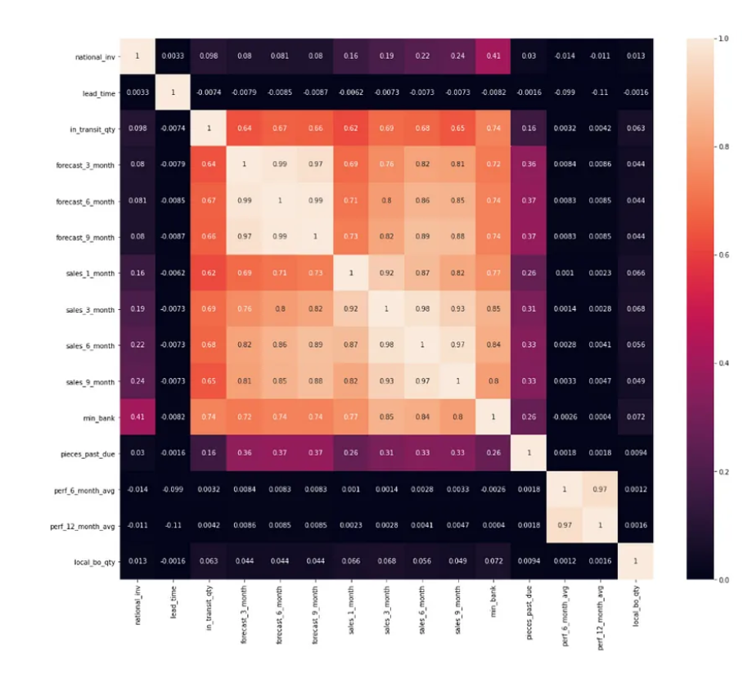**From the correlation matrix , we can easily interpret that features from in_transit_qty to min_bank are more correlated with each other. Also the perf_6_months_avg and perf_12_months_avg is highly correlated with each other.**

##### DATA PREPROCESSING

As a part of Data processing missing values are fixed using Imputation technique like Simple Imputer and MissForest Imputation. Data being highly imbalanced, oversampling techniques like Random Oversample and SMOTE have been used.

We are Converting categorical Features Variable to 0 and 1 along with Target variable.

Checked for Number of 0s in Numerical Features and drop columns if 0s are more than 95%.

Here We had removed columns that contain more than 95% of 0s.

We have alsoRemoving Outlier points.

We have divide the dataset into two parts using Train_Test_split into training Data used for Training Model and Test Data used for Evaluating Performance of model.

##### 

##### FEATURE ENGINEERING:

For Feature Engineering,We would use **OneHotEncoder** and Truncated SVD for Feature Extraction and will add these features to my dataset. Along with this We had also try Feature Binning and Discretization using Decision Trees of at least 1 Numerical Feature.

As a part of oversampling technique We had used SMOTE-NC as my dataset consists of Numerical and Categorical features.

##### MODEL DEVELOPMENT

As the data is imbalanced it would be better to go for Tree based models such as **Random Forest** ,XGBoost, Adaboost classifier. Initially I will be applying Logistic Regression. As a part of Custom Ensembles , I will be using Decision Tree as base model and Logistic Regression as Meta Classifier.

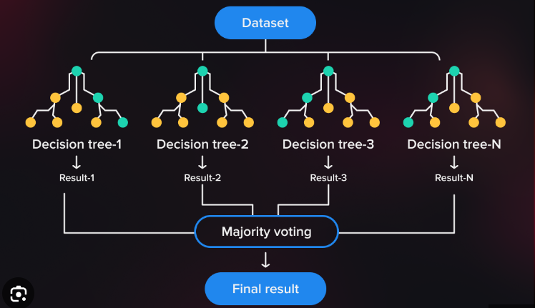

**Logistic regression:**

It is a classification algorithm based on given set of independent variables. It is used to estimate discrete values i.e 0s and 1s.Basically it measures the relationship between the categorical dependent variable and set of independent variables by estimating the probability od occurrence of an event using its logistic function.

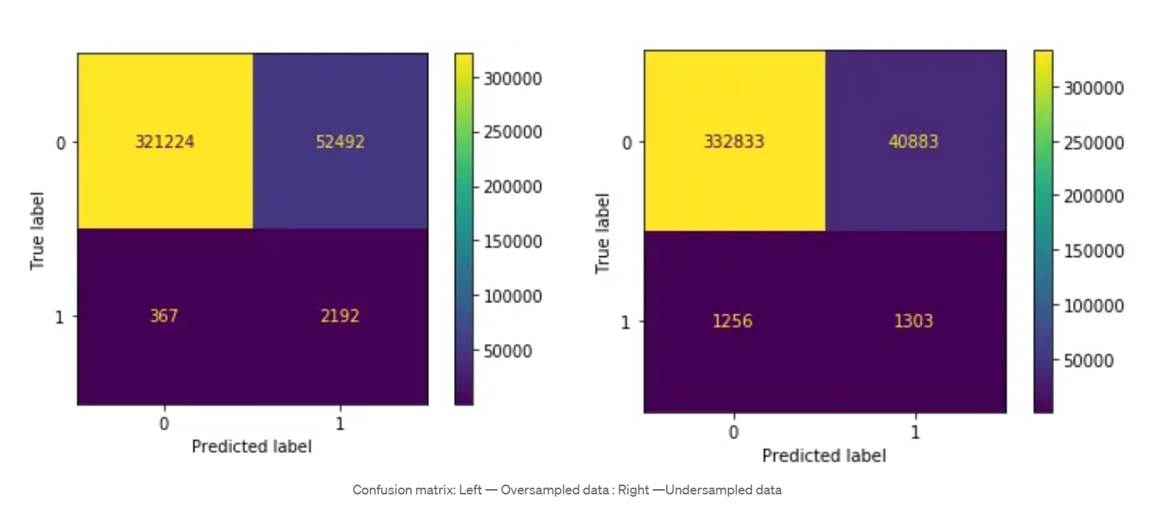

This provided a test F1-Score of 0.50 on oversampled dataset and 0.49 on under sampled data

***Random Forest:***

Random Forest is an extension to Decision Trees. It uses bagging strategy which involves Bootstrap and Aggregation. In this modelling technique in which several Decision Trees are trained on the train data and majority vote is taken between these many decision trees for classifying the points.

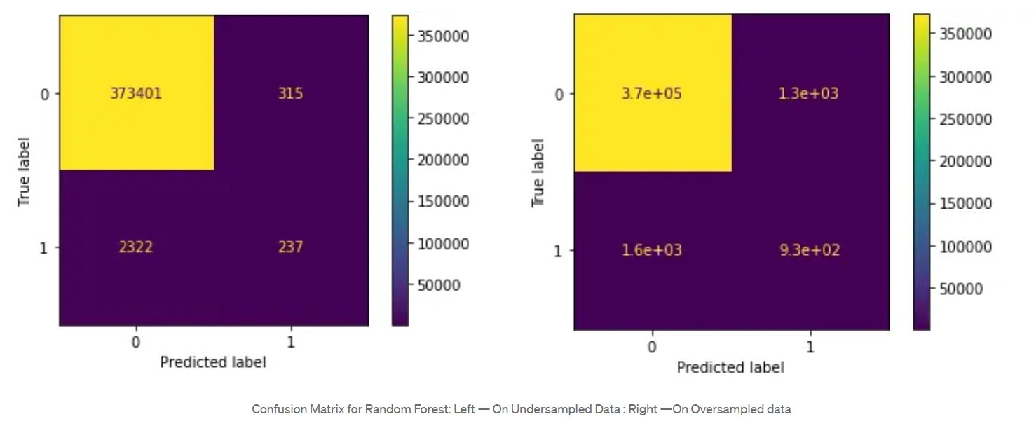

Test F1-Score was 0.69 on Oversampled dataset and 0.57 on Undersampled dataset

##### Code of project

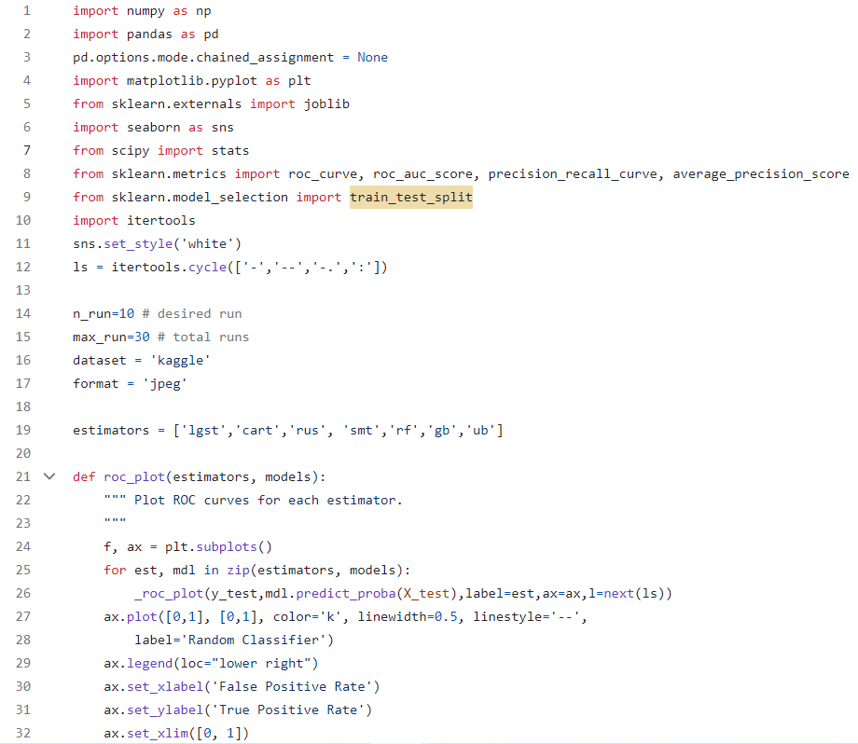

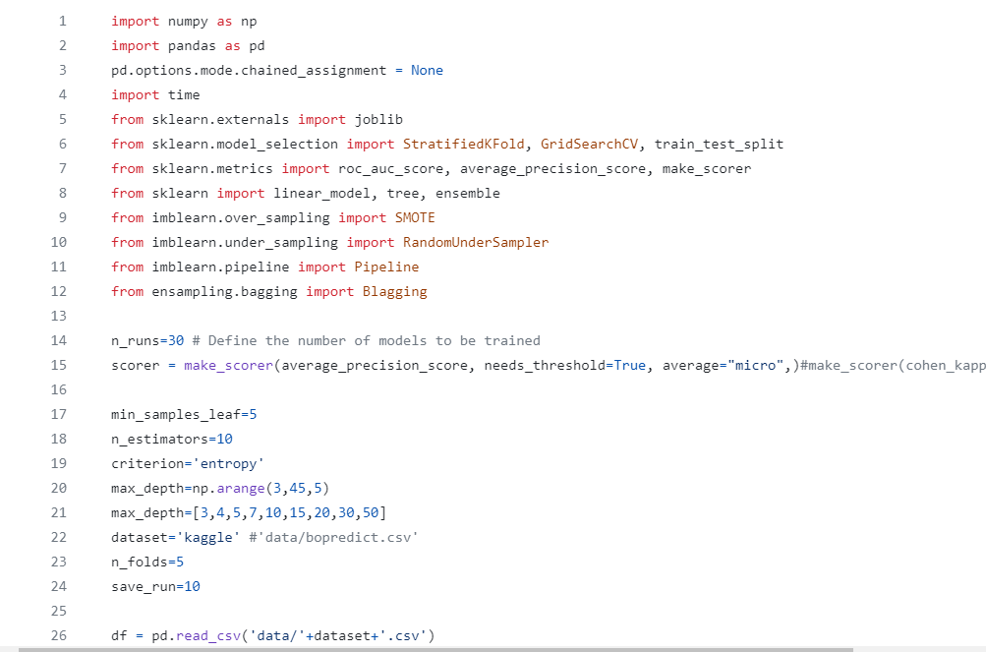 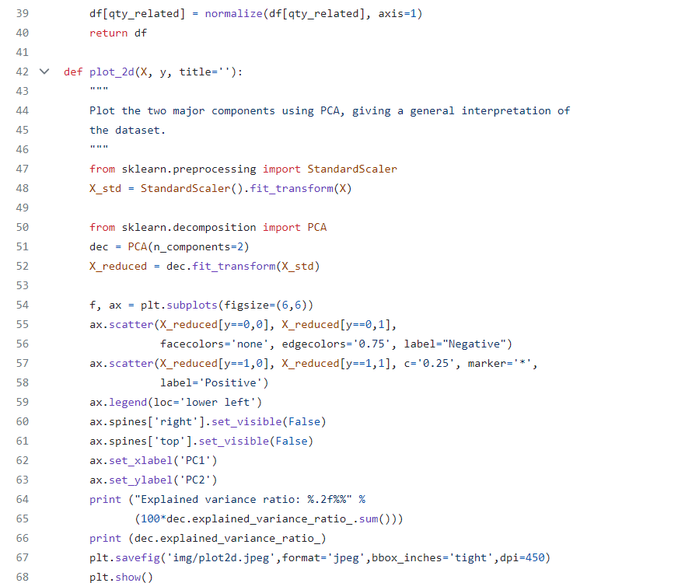

Limitations

**Data Completeness and Quality:**

Our analysis relies on historical data, subject to data quality issues, missing values, and potential inaccuracies. This may affect the accuracy of our recommendations.

and recent data might be more relevant. Our reliance on historical data might not fully capture current situations.

Backorders are not a common scenario in inventory management systems. In turn, the number of non-backordered items is much larger than the backordered ones. Hence, real-time data collected from any inventory system will be strongly imbalanced, leading to challenges in predicting future backorders on that basis.

##### conclusion

***We observe that with every model the improvement in f1 scores.***

***- We saw that the Model on oversampled data perform well as compared to Under sampled data, this could be because of loss of data while under sampling.***

***- Among all the models , Random Forest Model provided a f1 score of 0.69 and models including XG Boost and Custom ensembles gave a f1 score of 0.62.***

|  |  |  |
| --- | --- | --- |
|  |  |  |